Specializing In Affordable student Travel
A Contract Proposal for Chain of Lakes Middle School June 2-5, 2020
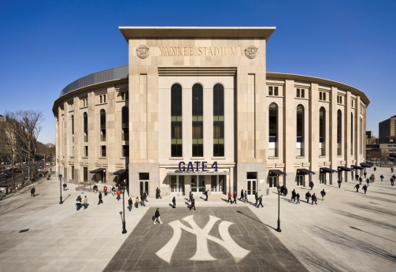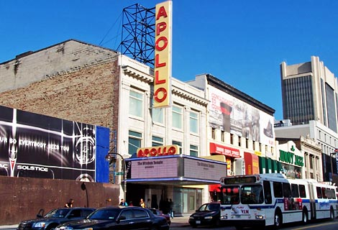

Attn: Lisa Barrows

Lisa Barrows
Drama Director
Chain of Lakes Middle School
Lisa.barrows@ocps.net
Phone:(407-909-5400) Fax:(407-909-5410)
https://chainoflakesms.ocps.net/academics___curriculum/subject_areas/drama

Hi Lisa this sounds like an exciting trip. We have planned 3 Broadway Shows and 3 professional workshops for your group. We included a few other sights in the itinerary too. Thank you for your interest in You Name It Tours. We strive for a custom experience tailored to your satisfaction! Our 23 years of experience with student travel gives us the ability to deliver the best experience at the best price. The custom itineraries, accommodations, and transportation plans have been carefully designed to optimize the quality of your travels, but are entirely flexible to meet your needs. We can adjust pricing based on program. Meals can be altered or omitted to adjust price. Just give me a call to tailor this trip a bit more. The cost can be affected by the time of year as well.
Contact us at any time during your planning process for information on rates, destinations, or accommodations of any kind. You Name It… and we can do it.
The bid and the Sample Itinerary for the Trip are below. We can be flexible in the booking process. Please contact us for any questions.
Flavio Morrissiey
You Name It Tours
Office 888-257-4099
Cell 407-948-6507 Cell
Email: ynitours@gmail.com
Orange County Public Schools Vendor # 1019828
Seller of Travel Ref. No. ST40006
Vendorlink id 27296

Payment Schedule can begin in September. (8 payments can be made or pay in full) Payment methods are checks, made out to You Name it Tours in person or mail to 3956 Town Center Blvd #371 Orlando, FL 32837. Credit Cards can be paid through our online booking system and are susceptible to fees. Website ynitours.com/colms

Monthly installment plan for students or parents
September 1st, 2019 | $50
October 1st, 2019 | $200
November 1st, 2019 | $200
December 1st. 2019 | $200
January 1st, 2020 | $200
February 1st, 2020 | $200
March 1st, 2020 | $200
April 1st, 2020 | $200
May 1st, 2020 $200
Itinerary Quote based on avg 20+ participants $1650pp adults or students

Late payments may cause automatic cancellation of your booking and charges will apply. Group has the right to ask for and/or suggest reasonable changes to the itinerary, and the cost of such changes will be negotiated separately. Proposed 05 / 02 /2019. The trip is fully refundable January 15th, 2020 before the trip.
By signing below you agree to the above terms and conditions.
Representative ______________________________________________ Date__________
You Name It Tours ________________________________________ Date__________

Itinerary
Day One June 2, 2020 Tuesday (Itinerary is sample and times may change) Lunch and Dinner *
5:00 a.m. Meet at Airport MCO
7:00 a.m. Check in and Depart Airport MCO
10:00 a.m. Approximately Arrive in New York Airport gather luggage
11:30 a.m. Transfer to City via AirTram
12:15 p.m. Arrive at Penn Station and walk to hotel 8 min walk
12:30 p.m. Check into hotel drop off bags and go to lunch on on 8th Avenue while walking to Radio City Music Hall
2:00 p.m. Radio City Music Hall Tour and St. Patrick’s Cathedral
4:00 p.m. Freshen up for Dinner and Broadway Show
5:00 p.m. Walking transfer Juniors Chees Cake 1515 Broadway, W 45th St, New York, NY 10019 (11 min walk)
7:00 p.m. Walking Transfer to Broadway Show TBA
9:30 p.m. Walk back to Hotel (20-30 min walk)
11:00 p.m. Lights out security on patrol

Day Two June 3, 2020 Wednesday (Itinerary is sample and times may change) Breakfast, Lunch and Dinner*
6:00 a.m. Breakfast at Hotel
6:45 a.m. Walking Transfer to Today Show or ABC Good Morning America
8:00 a.m. Depart morning Show
8:00 a.m. Hop on Hop off Bus Tour, Visit China Town, Little Italy, Battery Park and One World Observatory
11:30 a.m. Lunch in China town or Little Italy
1:00 p.m. Depart for Broadway Workshop
1:45 p.m. Arrive at Broadway 101 Workshop
4:15 p.m. Transfer back to hotel to freshen up for dinner and Show
5:15 p. m. Transfer to Dinner Ellen’s Stardust
6:30 p.m. Transfer to Broadway Show TBA
7:00 p.m. Broadway begins
9:45 p.m. Show is over transfer to Hotel
10:30 p.m. Security Patrol lights out

Day Three June 4th, 2020 Thursday (Itinerary is sample and times may change) Breakfast, Lunch and Dinner*
7:00 a.m. Breakfast at Hotel
8:00 a.m. Hop on Hop off to visit the Intrepid, Museum of Natural History and Central Park and Zoo
11: a.m. Lunch at Museum or box lunch to eat in Central Park
1:00 p.m. Transfer to Broadway Workshop
2:00 p.m. Workshop begins
4:15 p. m Transfer to Hotel to freshen up before Broadway show
5:00 p.m. Transfer to Dinner at Carmines before Show
6:15 p. m. Transfer to Broadway Show “Anastasia”
7:30 p.m. Show begins TBA
10:00 p. m. Transfer back to Hotel
11:00 p.m. Lights out Safety Patrol

Day Four June 5th, 2020 Friday (Itinerary is sample and times may change) Breakfast, Lunch and Dinner*
7:30 a.m. Breakfast at Hotel pack for trip
8:15 a.m. Transfer to Broadway Workshop
9:00 a.m. Arrive at Workshop
12:00 p.m. Transfer to Airport Lunch at Airport
3:00 p.m. Depart for Orlando (MCO)
6:45 p.m. Arrive in Orlando
7:15 p.m. Parents pick up students

Contact Us
For further details regarding marketing materials, participant names or special items you would like us to handle, let me know and we will take care of it. Please contact your trip coordinator, Flavio Morrissiey, with any questions pertaining to your traveling needs.

Get off on the Right Foot!

Flavio Morrissiey
Cell: 407-948-6507
Web: ynitours.com
Email: ynitours@gmail.com

